13th and 14t^{h} May 2019
Science Investigation Afternoons
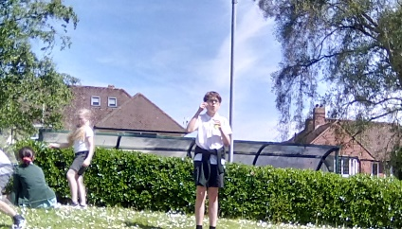
Year 5/6 took part in two science afternoons this week. We took part in an escape room type activity where we had to carry out some scientific enquiries to release secret agents from their prison. Along the way we had to crack codes too, to find out where the agents were being held.

- Freezing and Thawing
We had to release a key from a block of ice. First we used our hands to warm the ice but it took a long time. We considered other ways of thawing the ice – using warm or hot water, covering it with paper towels, leaving it in the sun or sprinkling salt on it.

We found that the warmth from our hands worked well, but it was a slow process. We then poured some warm water on it which sped the thawing up a little. Covering it with paper towels did not work so well. Finally we sprinkled it with salt and the key was released. (Salt works by lowering the freezing point of water via a process called freezing point depression. )

- Coke and Mentos experiment
Best performed outside, we needed a distraction to help us buy some time to find the secret agents. We dropped a pack of mentos into a bottle of coke and watched the ensuing explosion! When we examined the mentos, we noticed tiny little dimples covering its surface. All these little dimples provide a place for the carbon dioxide in the coketo latch on and undergo a physical reaction. The carbon dioxide from the soda can attach to these dimples and escape the liquid solution (the soda). Because there are so many dimples on the Mentos and because there is so much carbon dioxide in the soda solution the reaction is a big one.

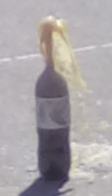
- Using red cabbage water as an indicator
Our task was to turn the purple water into different colours and back again in a particular order. We found that when we added vinegar (an acid) to the indicator it changed to a pink colour and when we added bicarbonate of soda (an alkali) it became a blue/green. We worked out that by adding an acid to the blue/green solution it returned to purple, then adding more acid changed it to pink. We also You can also tried testing salt. It did not make the indicator change colour - so we deduced that it was not acid or alkaline but was neutral (like water).

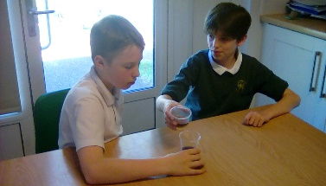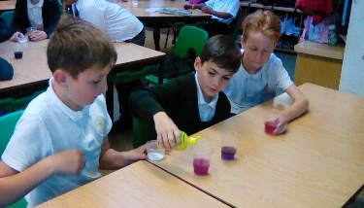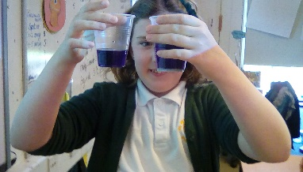

- Bubbles!
We were tasked with making our own bubble wands in various shapes and sizes, and we then set about experimenting with washing up liquid and water to see what the ideal ratio of soap:water was to make the best bubbles. We settled on 3 parts washing up liquid to 1 part water. The outside and inside surfaces of a bubble consist of soap molecules. A thin layer of water lies between the two layers of soap molecules, sort of like a water sandwich with soap molecules for bread. They work together to hold air inside.

Finley’s solution made the biggest bubbles which travelled furthest. He said that he had stuck to our ideal ratio.

We didn’t manage to make a giant bubble, but managed to pull a large film from our hula hoop. We decided that it did not work as we didn’t have enough mixture. Mrs Western discovered that it is very hard to take pictures of bubbles as they tend to pop before you can capture the moment….

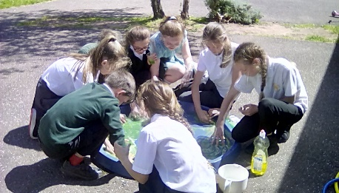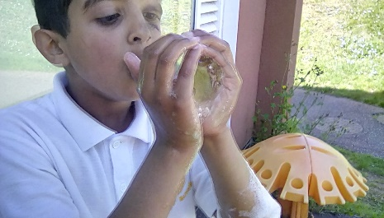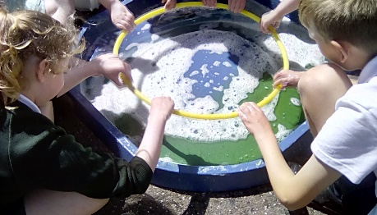

- Lemon Fizz
We were tasked with finding a way to send a message through a crack in a door frame and had only lemons and bicarbonate of soda. We cut the lemon into wedges, add a sprinkle of the bicarbonate of soda and it will fizz. The idea was that you could put into into a door frame and the fizzing bubbles would push through to make a signal. Lemon juice contains citric acid which when mixed with baking soda (sodium bicarbonate) reacts to form carbon dioxide and sodium citrate, which causes the liquid to fizz and bubble. We found that if we squeezed the lemons or poked holes in the flesh to release the juice we had a better fizz.
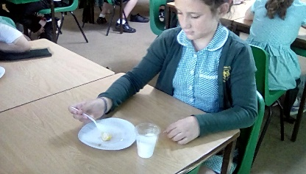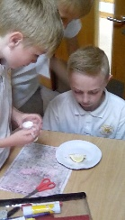
- Popcorn
As a treat for releasing the agents we made popcorn. We looked at the kernels for some time wondering how they could become fluffy and delicious rather than hard and unappetising. We put forward our theories on how this might happen and worked out that steam and water were involved. We related this back to our experiment with eggs and how some things change when they are heated. On microwaving the kernels they popped and became fluffy and light. We researched the science and found that we were right in our theory as when a popcorn kernel is heated, the trapped water in the kernel turns into steam, building up pressure inside the it. This pressurized, super-heated steam transforms the soft starch in the centre into a gelatinous material.

