9th May 2019
IALT investigate why some things rust and what rust is.

Nails and Rust Experiment
We all chose a question to investigate, then set up our experiments with a control sample. We will monitor these over the coming weeks.
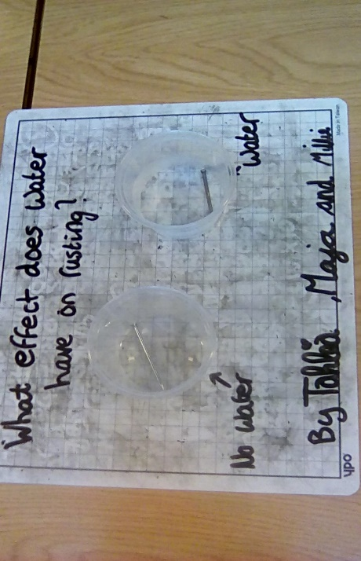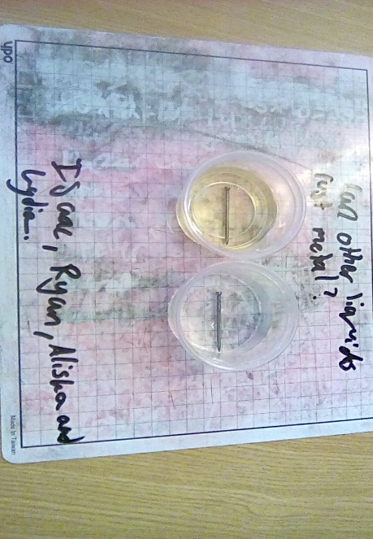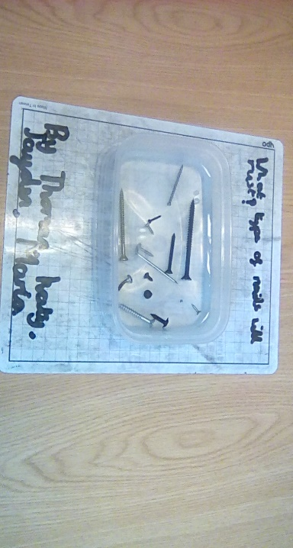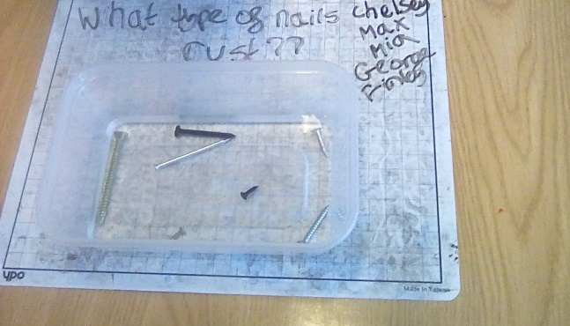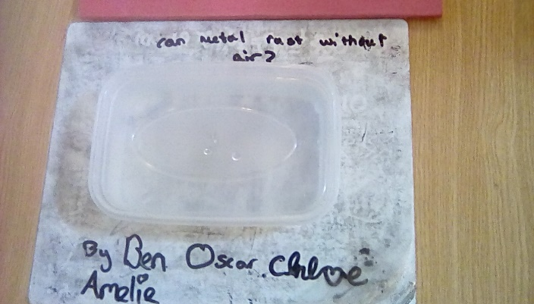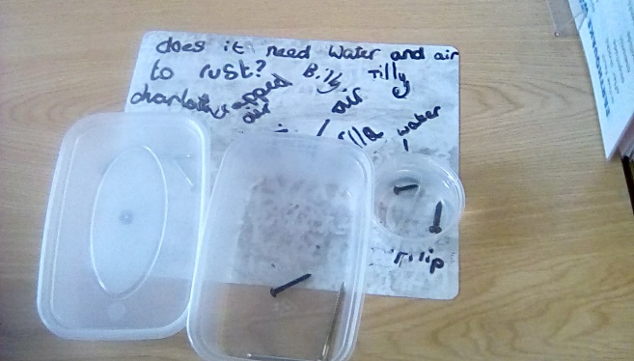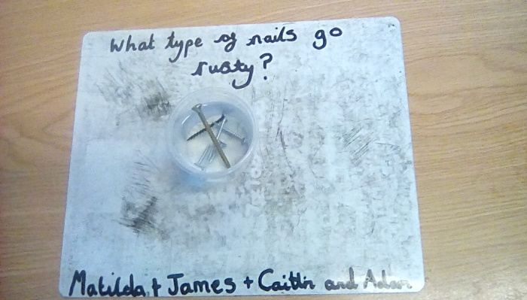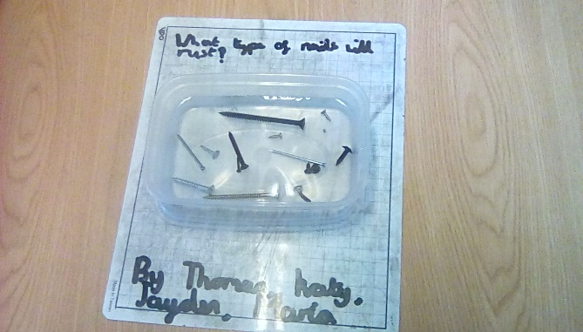

9th May 2019
Oxidation of Apples
Oxygen in the air can cause sliced fruit to brown, a process called enzymic browning (an oxidation reaction). We decided to investigate whether anything can slow or stop this process and predicted what might work. We coated one apple slice with either salt, sugar, citric acid, lemon juice or oil. We left one slice uncoated as a control sample.
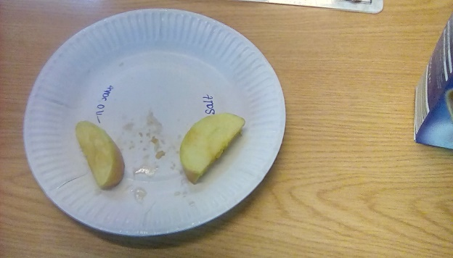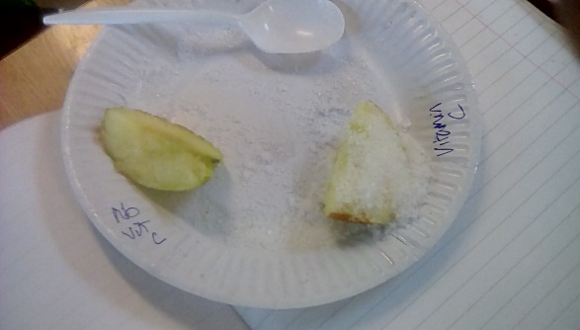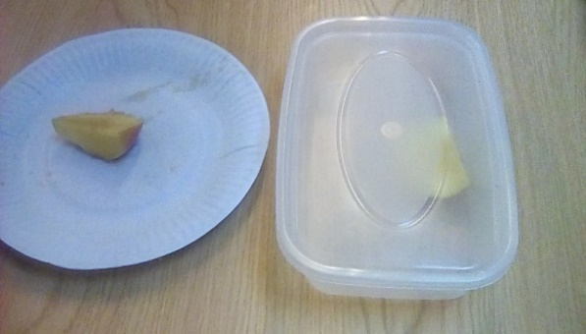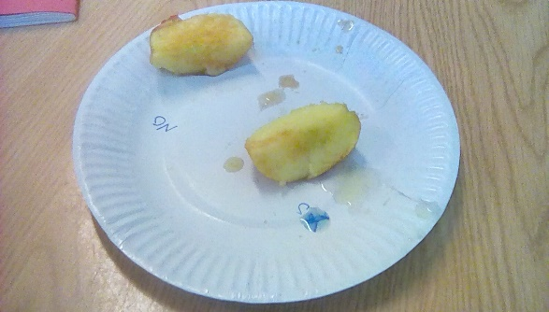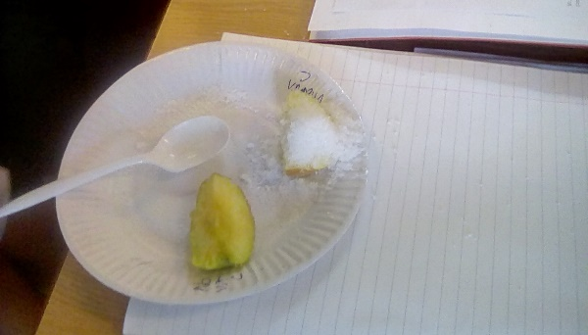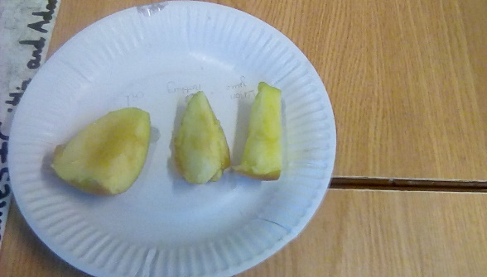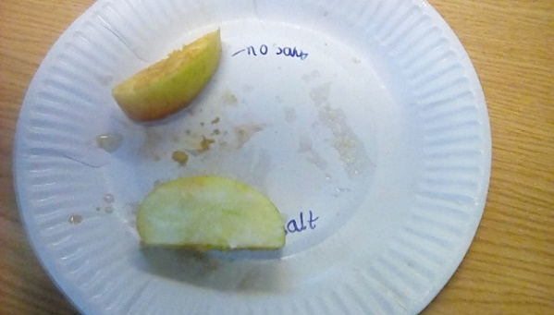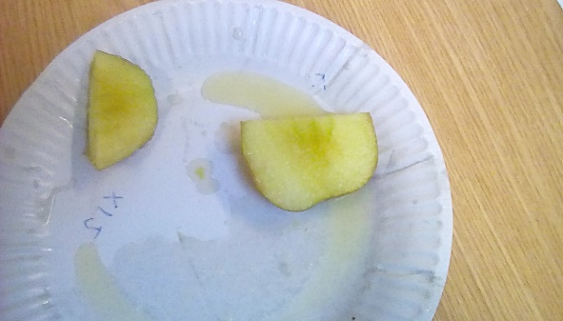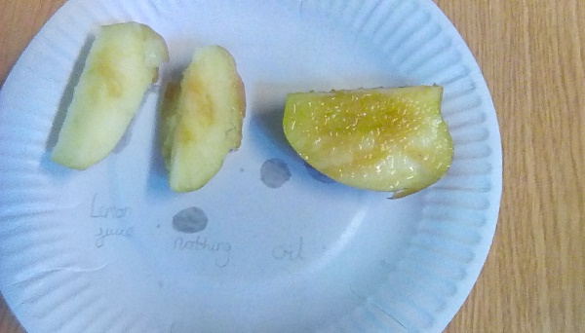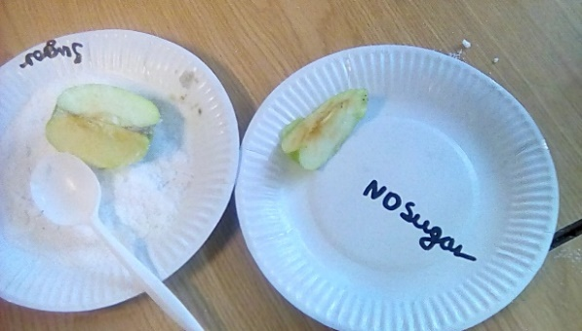
We cut up an apple and coated slices in the same amount of another substance to see how it affected the oxidisation process.

Apple | After 5 minutes | After 15 minutes
Apple (control slice) | Slightly brown | Very brown
Apple coated with salt | Some patches of brown where not completely coated | Patches of brown but not as much as the control sample.
Apple coated with oil | Slightly brown | Very brown
Apple coated in lemon juice | Unchanged | Unchanged
Apple coated with Citric acid | Unchanged | Unchanged
Apple coated with sugar | Unchanged where coated | Unchanged where coated.

After 5 minutes our control samples turned brown. The apple in the sealed container had also turned brown and we realised that there was still air in the box, so this investigate would only have worked if we had taken all the air out of the box or used a vaccuum sealed bag. Apples coated in salt browned less. Salt reduces the amount of water on the surface of the apple through osmosis as the salt has a lower concentration of water, slowing down oxidation. Lemon juice helps keep the apple from browning, because it is full of ascorbic acid (Vitamin C) and it has a low (acidic) pH level. Ascorbic acid works because oxygen will react with it before it will react with the polyphenol oxidase. The citric acid worked in a similar way. Coating the apples with sugar will put a layer between the apple tissue and the outside world, but more importantly, the sugary solution reduced the diffusion of oxygen through the apple cells.

