LEGO LUNCH

“Lego Creator” Pizza Margherita Squares with “Marvel “Potato Wedges

Thursday 4th October 2018

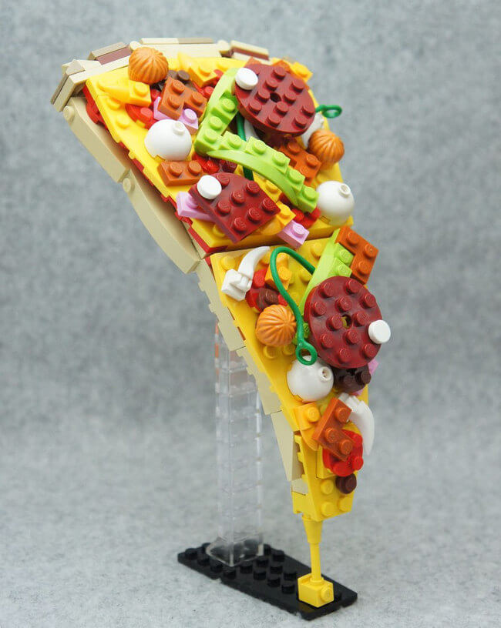 [](https://www.google.co.uk/url?sa=i&rct=j&q=&esrc=s&source=images&cd=&ved=2ahUKEwjY_OGjmubdAhVNExoKHQvxBwoQjRx6BAgBEAU&url=http%3A%2F%2Flegouniverse.wikia.com%2Fwiki%2FFile%3AStewblaster.png&psig=AOvVaw3iCvVnEAe3DTkyiGNnzar3&ust=1538516334188502)

Cheese ”Wheel Barrow” and “Marvel” Potato Wedges

“Awesome” Baked Potato

with Cheese

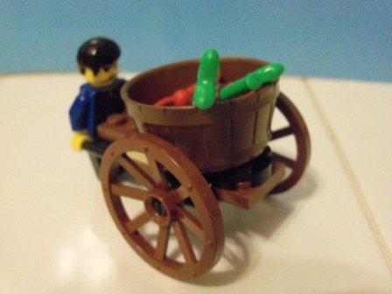

“Lego Super Hero’s” are hard at work preparing “Mini Figure” mixed Vegetables!!

L 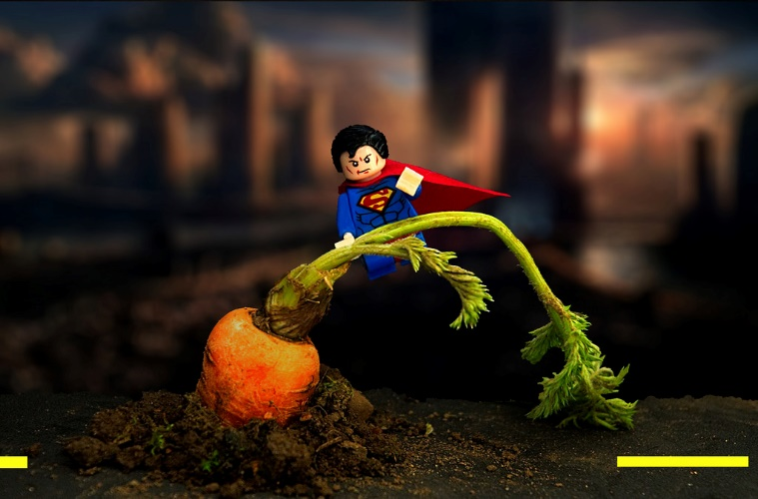

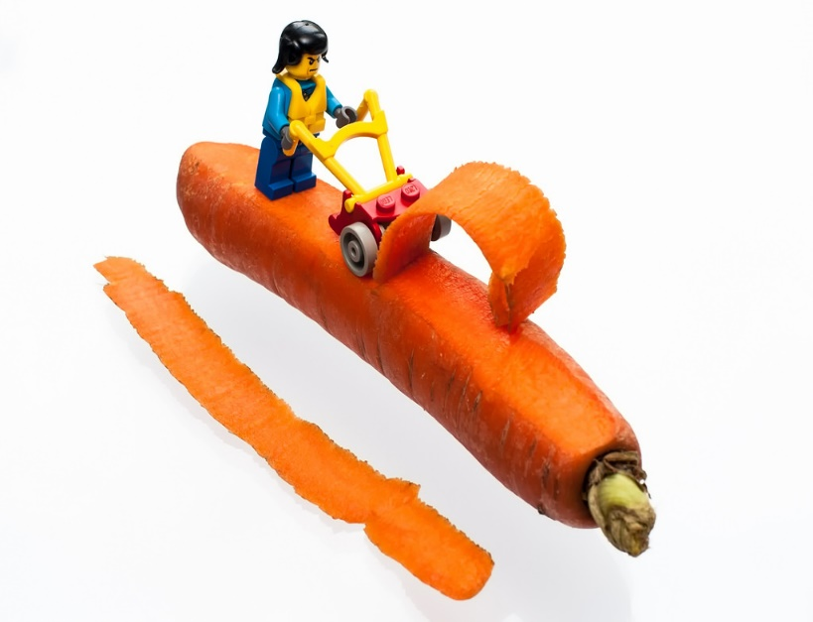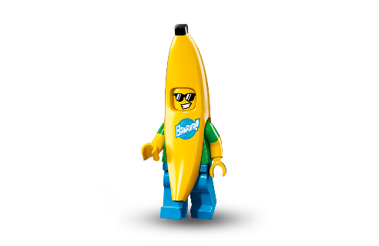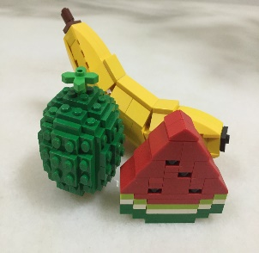

“Super Hero” Salads and fruit available from our new Salad Bar

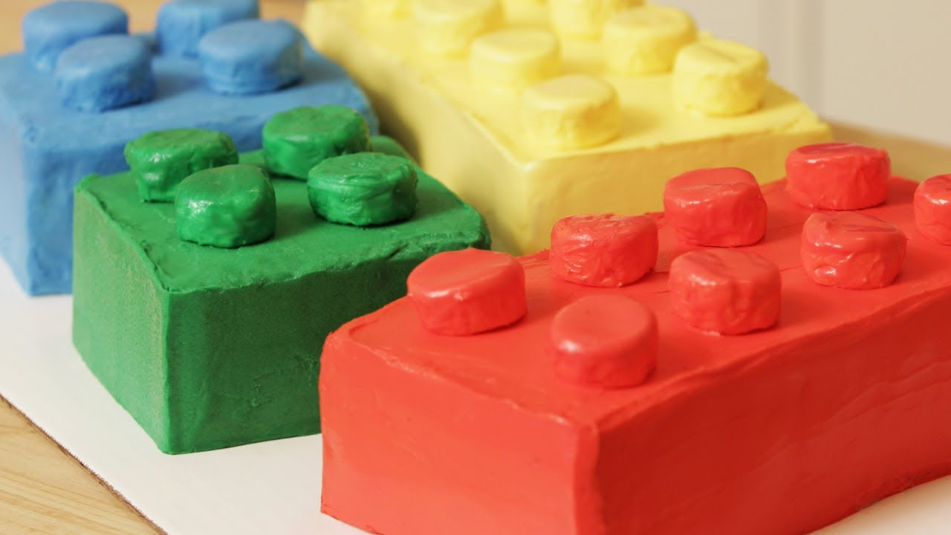

“Lego Brick” Cake or

“Lego Friends” Fruit

“Ninjago” Fruit Juice

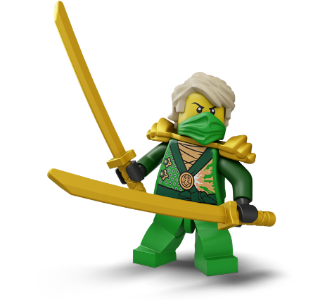

“LEGO BRICK” FOOTNOTE!

WE CAN BUILD DAIRY FREE AND GLUTEN FREE LEGO VARIATIONS