2nd May 2019
Report for the Science Museum
The Chemistry of Cooking: mixing, heating and burning

We looked at mystery recipe cards, considering the ingredients and trying to work out what the end result would be. Having done this we talked about how some changes that happen in cooking are irreversible. We then moved to the DT Room to do some cooking!
Eggs and Toast
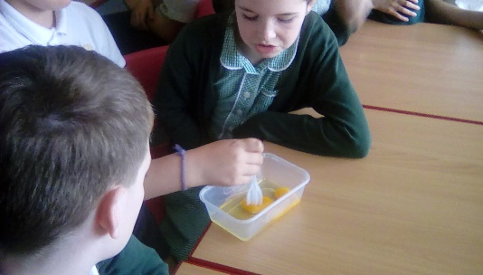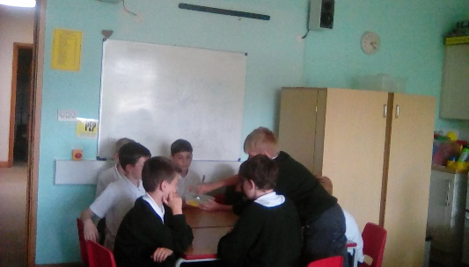
We broke our eggs into our container and mixed it, looking at how wet it was. We then cooked it in the microwave to make a very unappetising omelette. Everyone agreed that they would change when they were cooked, and be a little less sticky. Having cooked them we asked “are they still eggs – can we turn them back into their raw state?” We agreed they were still eggs, but they had changed and that change was irreversible.
Meanwhile, we had put bread into the toaster and left it in a little too long. A new product had been made – carbon (with other bits). We agreed that burnt bits are not good for us because of the chemical changes that have occurred.
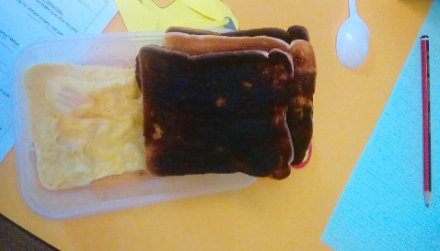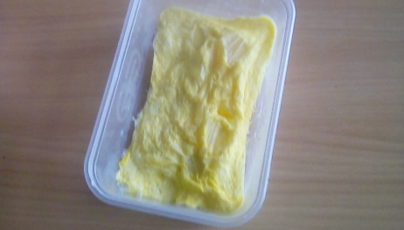
Returning to the classroom, we looked at some other products of chemical reactions with food. We put used yeast, sugar and warm water into a bottle and placed a balloon over the top. The balloon inflated because the yeast (an organism) was using the sugar as food and releasing carbon dioxide.
We then tried to inflate the balloon using vinegar and bicarbonate of soda. We put the vinegar in the bottle and added bicarbonate of soda. This time the reaction happened much more quickly and the balloon inflated very fast (and a little explosively). The two ingredients reacted to create carbon dioxide.
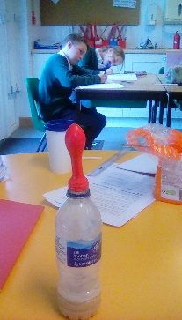
What reactions could happen if you did some cooking at home????

